**A New Approach to the Minimum Wage in California**

Author: Vinay Maruri

State level minimum wages have been a hot economic topic recently, as voters in Arkansas and Missouri approved measures this month to raise the minimum wages in those states to $11/hour and $12/hour respectively. In fact, according to the Economic Policy Institute, 21 states and the District of Columbia have raised their state minimum wages since January 2014.7 They have done this because the federal minimum wage, last raised in 2009, has not kept up with inflation and rising costs of living, leaving many families earning poverty wages around the country according to a Government Accountability Office (GAO) study released in October 2017.9 The report found that 40% of the U.S. workforce earned less than $16/hour, and that most of the households of these workers were impoverished even with the use of federal social safety net programs.

One of the states that raised their minimum wage was California. In November 2016, voters overwhelmingly approved a plan to raise the minimum wage in California from $10/hour to $15/hour in increments from 2017 to 2022.8 The incremental raises were motivated by a desire to give low-income workers a raise, while not overburdening businesses with rapid cost of labor increases. California’s plan should increase the purchasing power of households with minimum wage earners, as over time, the purchasing power of the minimum wage in California has been eroded by inflation as figure 1 shows below. Its purchasing power peaked in 1968.

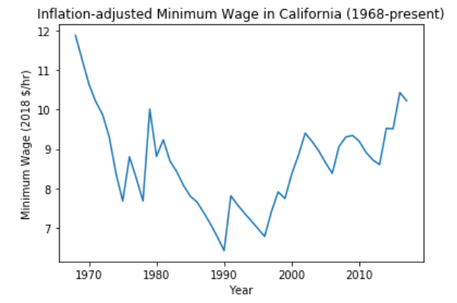

***Figure 1***

However, despite the increases in the minimum wage, California still has the highest poverty rate in the nation according to a Census Bureau report released in September.10 At 19%, almost 1 in 5 Californians live in poverty, struggling to get by. This is largely due to the high costs of living in the state, as Californians pay some of the highest prices in the nation for housing, gasoline, food, and taxes.11, 12, 13

Furthermore, as Tables 1 and 2 show, the costs of living are not similar around the state. Using data scraped from the MIT Living Wage model,4 which generates a living wage estimate for a family to meet the minimum costs of necessities such as food, childcare, housing, transportation, healthcare and other basic goods,1 a pattern emerges of higher cost of living in urban counties with medium to large cities and lower costs of living in rural counties with smaller towns. This pattern is not isolated to the San Francisco Bay Area or the Los Angeles Metropolitan Area. For the average American household of 2 adults and 1 child, 1 adult would have to earn $26.49/hour working a full-time job for 40 hours a week to provide that household with a livable wage in Santa Barbara County, which is outside the Los Angeles metro area. That living wage rate is lower than in neighboring Ventura County and the same as in Los Angeles County, both of which are part of the Los Angeles metro area. In fact, in every county of the state, a worker would have to earn from $21 to $36 per hour to provide the average household with a livable wage according to the MIT Living Wage model.

Given that the minimum wage is only scheduled to rise to $15/hour by 2022, California’s minimum wage plan does not provide households with a livable wage across the state, and in some counties, may not provide a livable wage to households with 2 adults working minimum wage jobs. A change of direction in minimum wage policy is needed to the generate socially optimal outcomes of lower adult and child poverty rates in California.

One possible way to do this would be to set minimum wage rates on the county level rather than on the state level. The idea behind this proposal is to account for cost of living differences across different areas of California, while setting wage rates to cover the market costs of living in various regions of the state. Intuitively, a worker’s income will cover more expenses in Fresno, which has lower costs of living, than in San Francisco, with some of the highest costs of living in the nation.

To test this idea, I built a linear regression model, predicting the percent difference between a county’s living wage and the state minimum wage using two variables. First, a variable for county-level poverty rates from 2016 and second, an indicator variable to denote whether a county was rural or urban using the federal government’s definition of rural and urban counties.5

The results of the regression showed that a rural county with a high poverty rate should have a low percent difference, whereas a low-poverty, urban county should have a high percent difference. This regression result means that the booming urban areas of California are predicted to be expensive to live in, and that there is a higher difference between the state minimum wage and the estimated hourly wage a worker would have to make for a family to live a bare subsistence life above the poverty line in urban areas than in rural areas.

The regression results, as shown in figures 2 and 3, show that both variables, poverty rate and the urban/rural indicator variable, had statistically significant effects on the predicted percent difference between a county’s living wage and the state minimum wage.

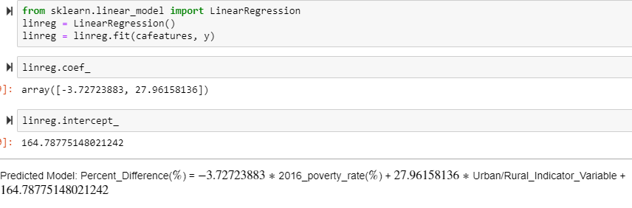

***Figure 2***

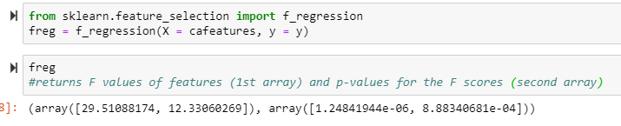

***Figure 3***

On a policy level, the data in tables 1 and 2 show that the current minimum wage in California, as well as the scheduled increases, are insufficient for the minimum wage households in California to earn a livable wage, without the fear of living in poverty. Furthermore, the regression results confirm that the different counties of California would benefit from setting different minimum wage rates, as such a policy would have an appreciable effect in accounting for the different characteristics of the counties.

Setting minimum wage rates at the county level could conceivably reduce poverty rates across California by setting a livable wage for households to subsist on in their home counties, while not setting an unreasonably high rate for businesses that cannot afford to pay San Francisco wages to their employees in Bakersfield. County by county minimum wages would be a more tailored approach to the problem of combatting poverty in California than a flat minimum wage across the state. Such a policy would go a long way to combatting the large problem of poverty in California.

## Appendix

**Citations**

1. http://livingwage.mit.edu/resources/Living-Wage-User-Guide-and-Technical-Notes-2017.pdf

2. https://www.kaggle.com/lislejoem/us-minimum-wage-by-state-from-1968-to-2017

3. https://data.chhs.ca.gov/dataset/living-wage/resource/f5a57e7a-e0fe-4d80-b0f6-92d66ecb907f

4. http://livingwage.mit.edu/ (data scraped from this site for all CA counties for 2018.)

5. https://www.ers.usda.gov/webdocs/DataFiles/53180/25559_CA.pdf?v=0

6. https://scdd.ca.gov/wp-content/uploads/sites/33/2018/01/Exhbit-A-SCDD-2016-California-Poverty-Levels-by-County.pdf

7. https://www.epi.org/minimum-wage-tracker/

8. https://www.sacbee.com/news/politics-government/capitol-alert/article156853119.html

9. https://www.gao.gov/products/GAO-17-677

10. https://www.census.gov/content/dam/Census/library/publications/2018/demo/p60-265.pdf

11. https://www.usnews.com/news/best-states/articles/2018-06-20/the-10-states-with-the-highest-average-gas-prices

12. https://www.forbes.com/sites/samanthasharf/2017/11/28/full-list-americas-most-expensive-zip-codes-2017/#43a5230c5d19

13. https://www.epi.org/resources/budget/budget-map/

**Tables**

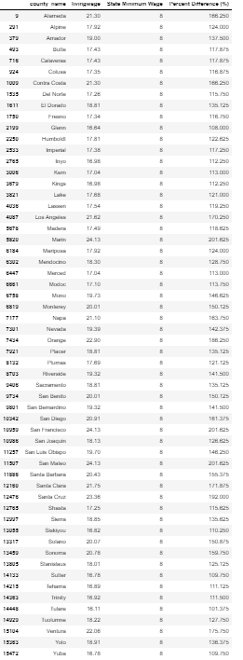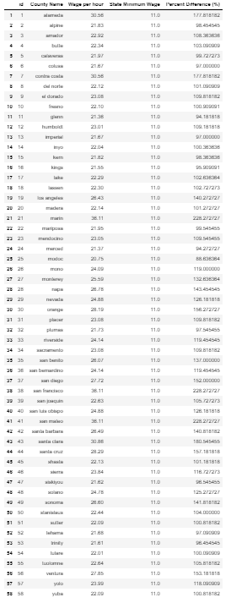

***Table 2- 2018 data***

***Table 1- 2010 data***

**Assumptions**

1. Because the federal government assumes the typical family size is 2.54 people, living wage data displayed is for a 2 adult, 1 child family.

2. Because the California HHS dataset assumes this type of family has one worker, the living wage displayed is what one worker would need to make per hour in that county.

3. County living wage data was taken from the MIT Living Wage Calculator. Their definition of a living wage is: "a 'step up' from poverty as measured by the poverty thresholds". It accounts for the basic needs of a family. This means it is the minimum subsistence wage for persons living in the United States to live without public assistance and housing or food insecurity.